Singly Linked List Code & Syntax

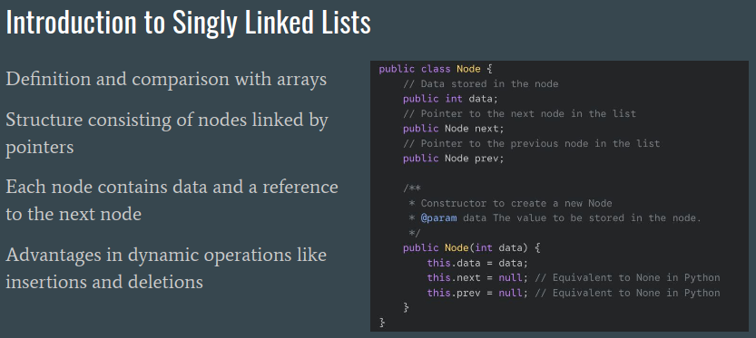
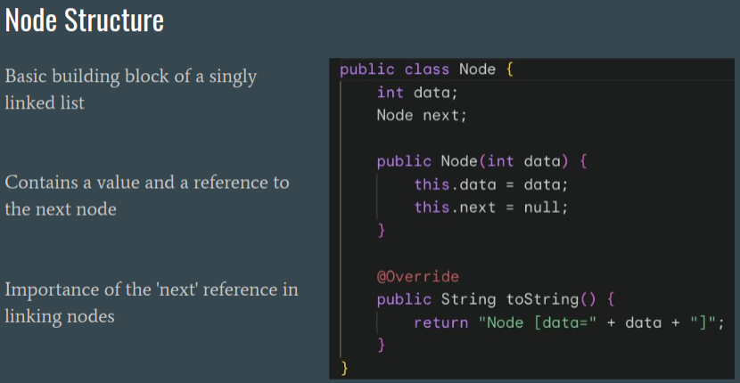
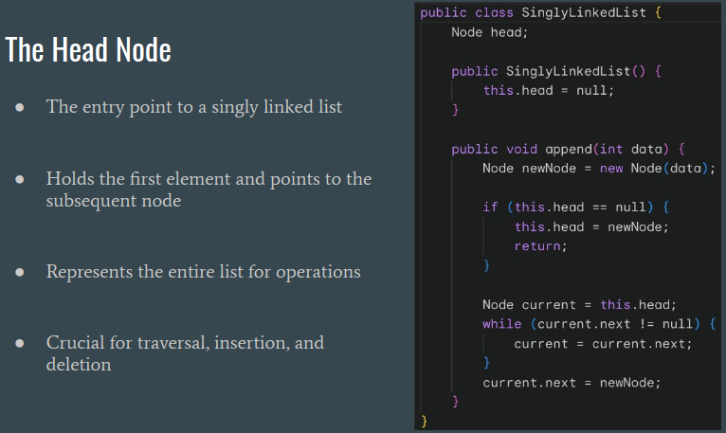
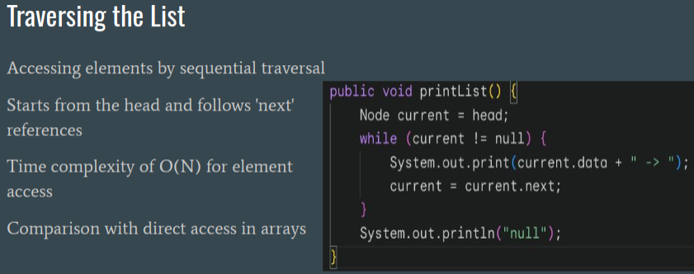
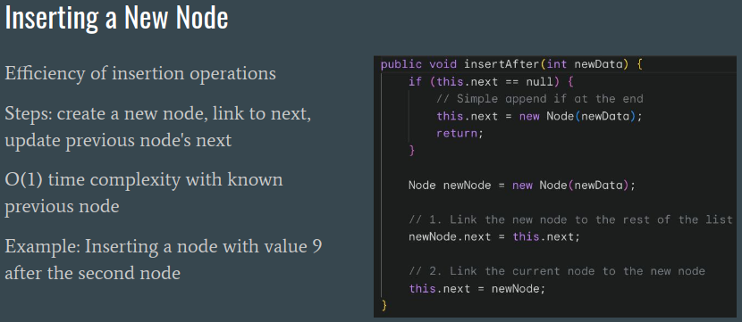
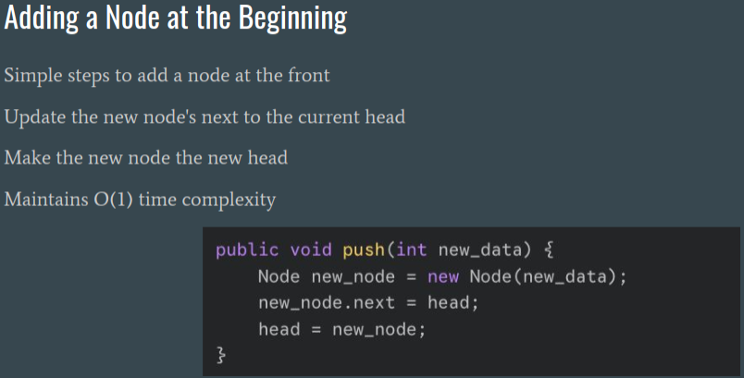
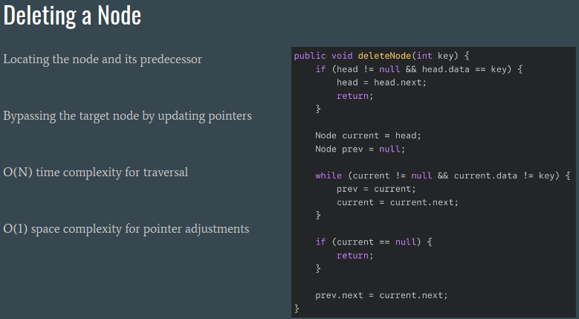
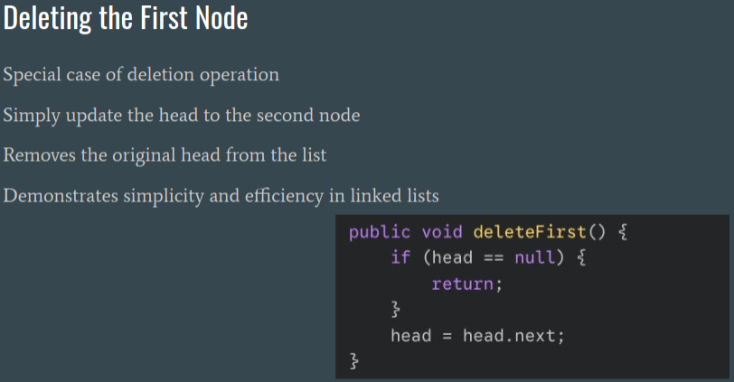

Available Prompt

I have an assignment (Integrating Patient Records from Two Healthcare Providers) using Java Language Doubly LinkedList concepts with in a syntax that presented in screenshots and Background and Objective below, including Assignment details below. Please provide me DETAILED, step by step, EXPLANATION on how to put the program together, and what filenames, files, and directories need to be created for OOP purposes using the same syntax techniques presented in the screenshots. After assignment code complete, generate me test code, given that I'm using VS code IDE, the way its done in industry with properly setting up directories and files to present test cases and demonstrate that I'm passing those cases.(industry expect me to have at least 3 test cases testing normal cases and at least 3 test cases testing edge cases). At the end of this assignment, prepare me a README file for this assignment with sections on how it works, including features section and how to run it section with demo table (.md syntax) for YouTube links to include the video presenting this assignment. Assignment as follows:

Doubly Linked List Code & Syntax

